2016 VETERAN AND VINTAGE VAUXHALL
AUTUMN RALLY

By Dave Stuart

The first of the Australian Vauxhall Register biannual rallies was organised and run from the Hume Weir Resort near Albury in N.S.W. on the weekend of the 7th and 8th May with entrants to arrive on Friday the 6th. Forty two cars were entered from Victoria, South Australia, New South Wales and Queensland. They were made up of A Type, D Type, 14-40’s, 20-60, 23-60’s and 30-98’s.
Entrants and cars from N.S.W. were:
Peter Weir and John Close 1909 A Type Vauxhall
Wayne and Olwyn Merton 1920 D Type Vauxhall
Gary and Carol Rickard 1922 23-60 Vauxhall
David and Mary Stuart 1923 23-60 Vauxhall
Euan and Wilga Coutts 1924 23-60 Vauxhall
Alex, Rosy and Orlando Hayward 1926 23-60 Vauxhall
Richard and Emi Walton 1923 30-98 Vauxhall
Jim and David Weir 1924 30-98 Vauxhall
Vic and Warwick Nicholson 1926 30-98 Vauxhall
To ease the journey to the rally the Weirs, Mertons, Coutts, Haywards, Waltons and Stuarts decided on a two day run to Albury with the others driving straight to the Hume Weir Resort on the Friday. We were to branch off the Hume Highway at Gundagai to overnight in Tumbarumba. We enjoyed beautiful autumn weather and those taking the two days all met at Roses Cafe in Goulburn on the Thursday at 10am. From there we rejoined the Hume to Gundagai for our lunch stop at a bakery in the main street. Following lunch we took the scenic road through Brungle to Tumut, then on to Batlow to arrive at our Motel in Tumbarumba about 4.30pm where the temperature had cooled down considerably.
The following morning we travelled south towards Tooma and stopped at the lookout where there is a well documented history of the air crash of the tri-engined aircraft Southern Cloud in 1931 in the distant mountain range towards the east. The wreckage was not found until 1958.
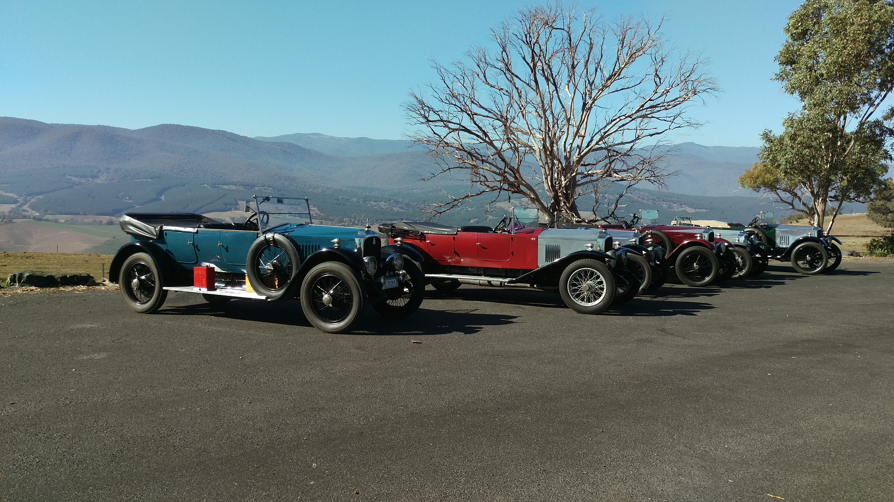
Vauxhalls at the Southern Cloud lookout near Tooma
Following lunch at Tallangatta it was a relatively short run for us into the Hume Weir Resort. After we had all booked it was time to register for the rally and we met the organisers Justin Coxhead and John Kent to receive our rally packs. The usual happy hour followed and drinks were provided for all from the Vauxhall Inn mounted on the rear of my 23-60 and this gave us time to catch up with other Vauxhallians from Victoria as well as South Australia and Queensland. Dinner followed later in the dining room then it was off to bed all very tired and glad to see the end of the day which again was superb autumn weather and most suitable for driving our vintage Vauxhalls.
Saturday’s run saw us leave at 8.15am to take a very scenic run around the northern side of the Hume Weir catchment to Old Tallangatta then on to Mount Beauty for fuel and coffee. The weather was glorious, clear blue sky and the colour of the trees magnificent. It was at Mount Beauty we visited V.S.C.C. member John Stanley and viewed his magnificent collection of Stower cars and other interesting items in his collection. Then it was off for the steep climb over Towonga Gap and down into the picturesque township of Bright for our lunch stop. The autumn colours on the trees made our stop most enjoyable as did the lunch and local beers we enjoyed at the local brewery where we lunched.
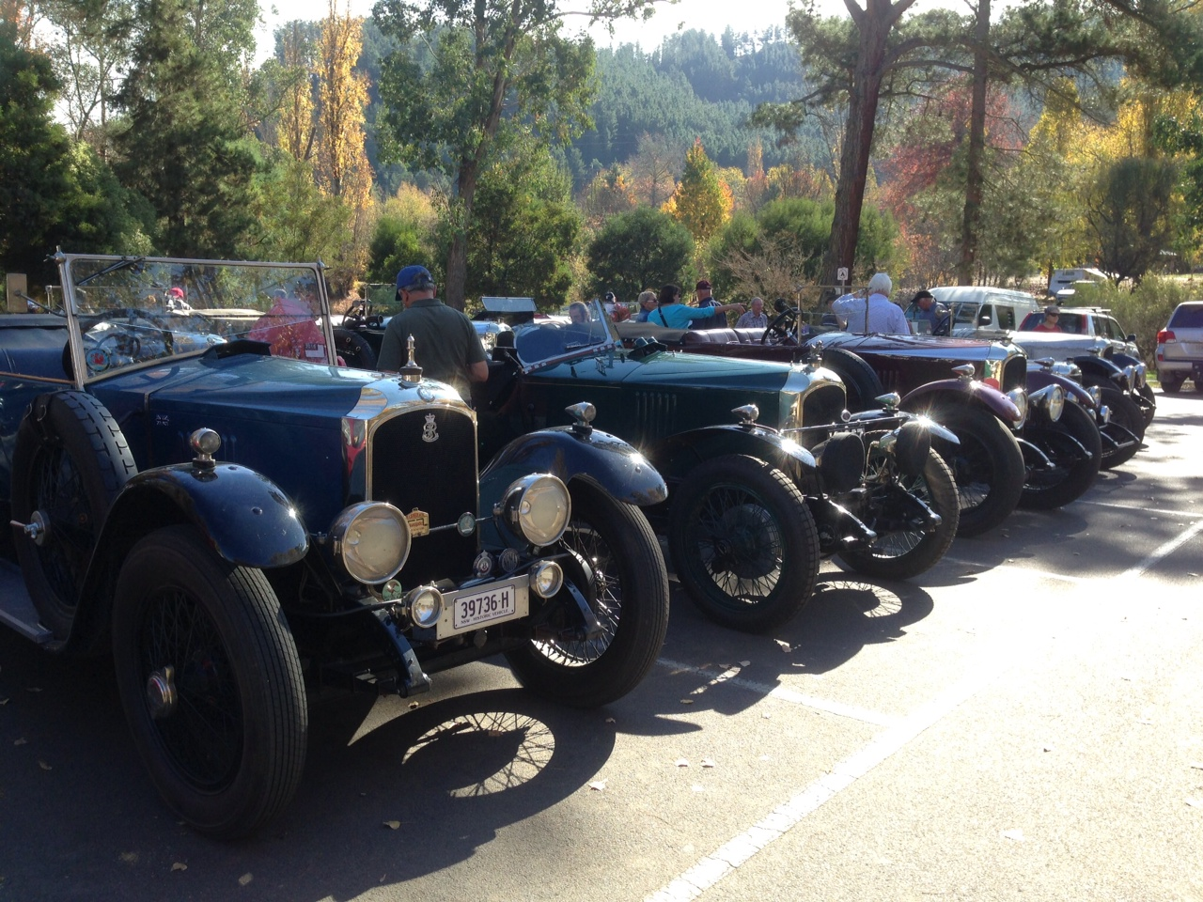Vauxhalls in the car park at Bright
Following lunch we motored on to the historic townships of Beechworth and Yackandandah, however running short on time we did have time to
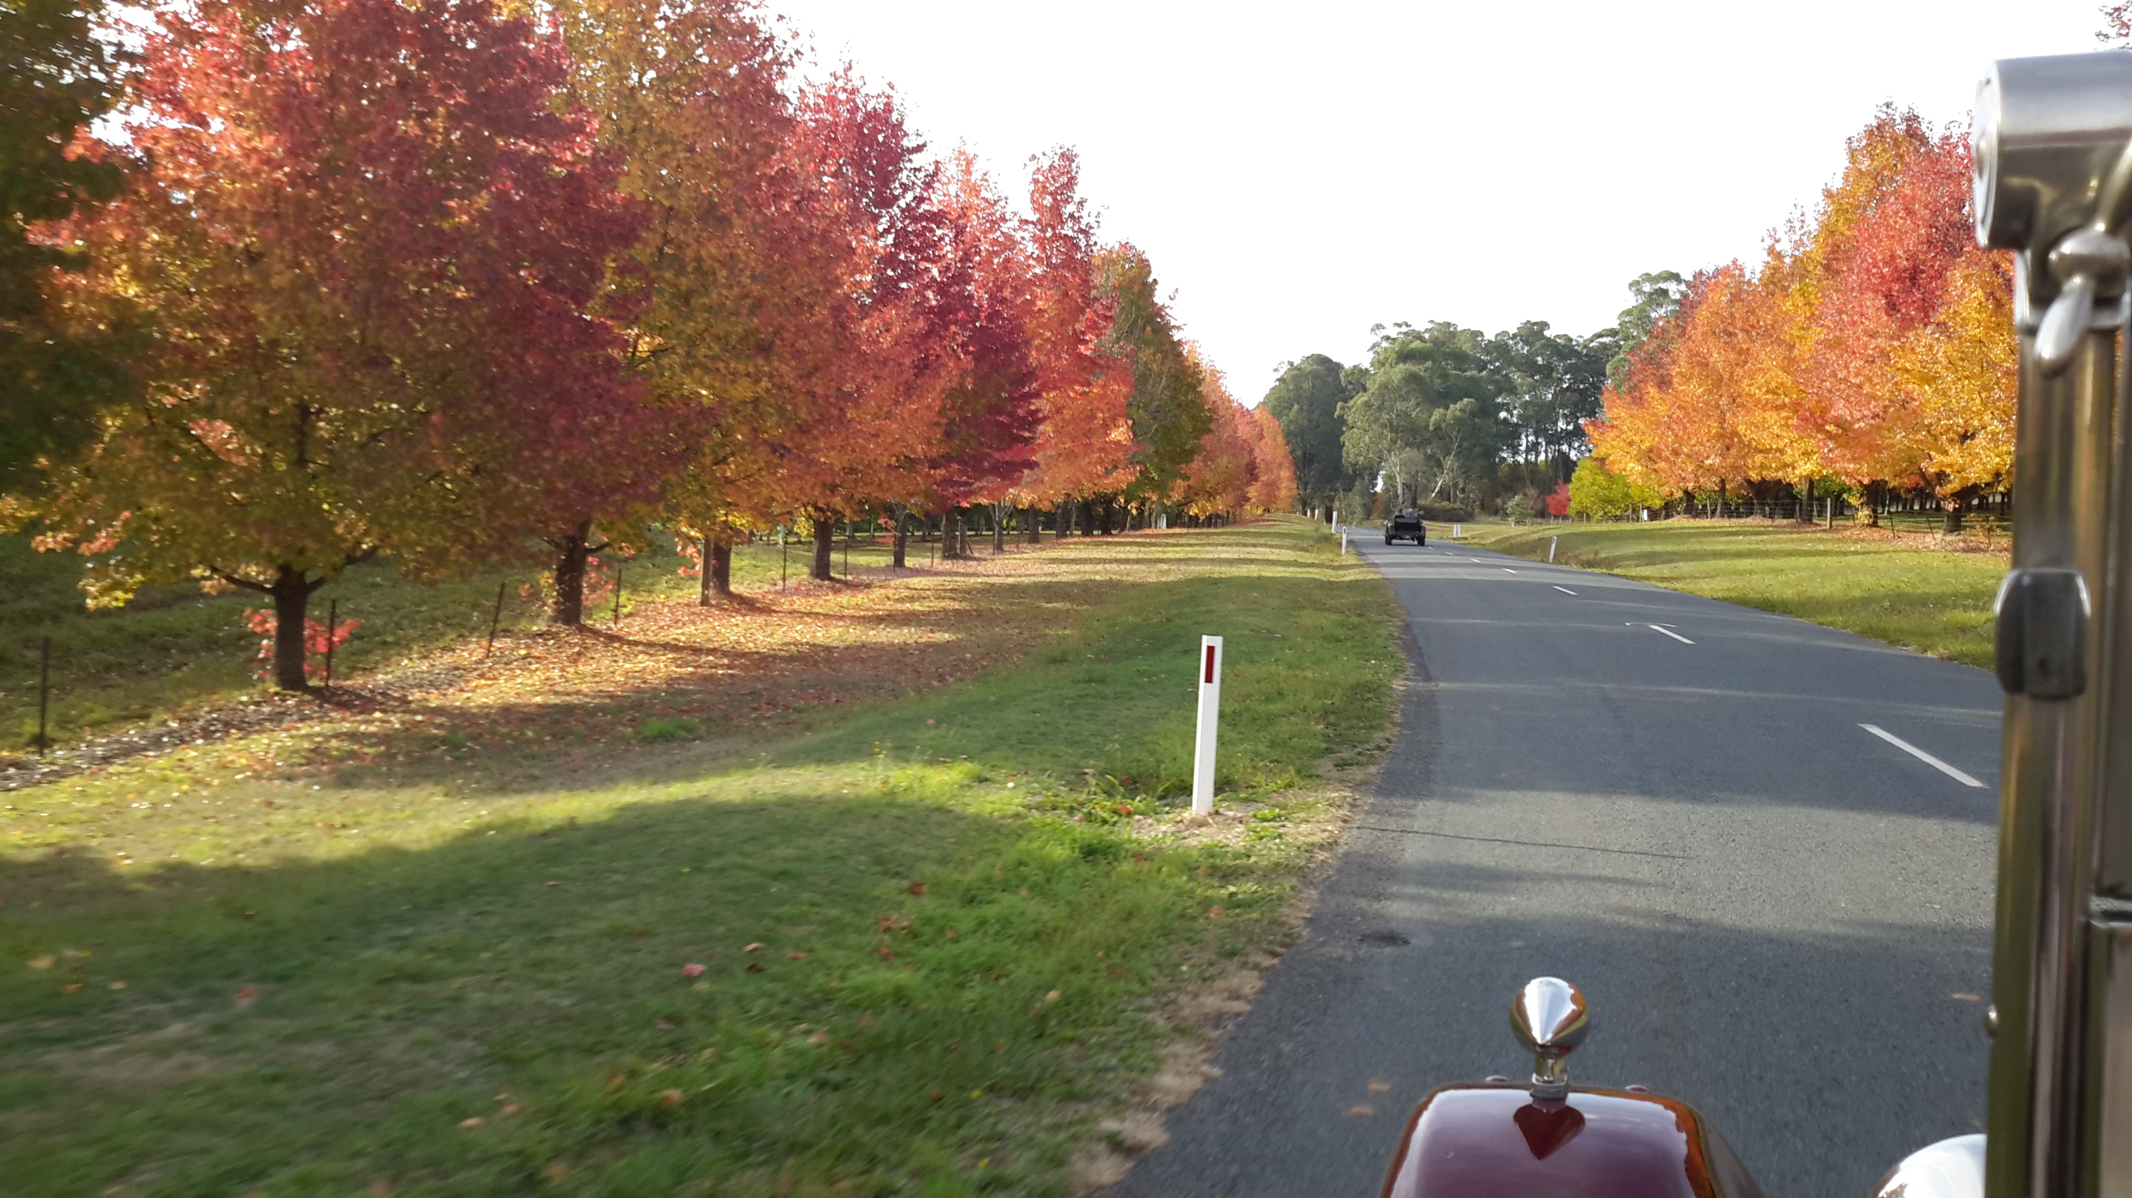Autumn colours as we approach Stanley near Beechworth
appreciate what each had to offer. We arrived back at the Hume Weir resort around sunset and another happy hour and barbecue dinner followed in the outdoor area near our rooms.
We had been watching the Elders Weather forecast for a number of days as the Sunday was reported to greet us with torrential rain with some 40 to 80ml. Well they got that right, it commenced raining during the night and when we woke up there was more of it. Some of the cars were reluctant to start obviously wanting to stay at home for the day however as we had pre-booked lunch at the lovely little pub in Jingellic situated beside the Murray River we all made a concerted effort to get going. We missed the first leg of the day’s event and drove straight to the pub along the River Road through constant rain and a little fog, however when we arrived we found all the cars had arrived and everyone was tucking into a big roast dinner of either local beef or lamb.....their beer was just as good. Following lunch we drove into Walwa and had some coffee and cake which complemented our country roast lunch at the pub. The drive back to the resort back along the River Road was again fairly slow and again in rain. We caught up to a group of Vauxhalls travelling along behind a 14-40 and joined them to the resort.
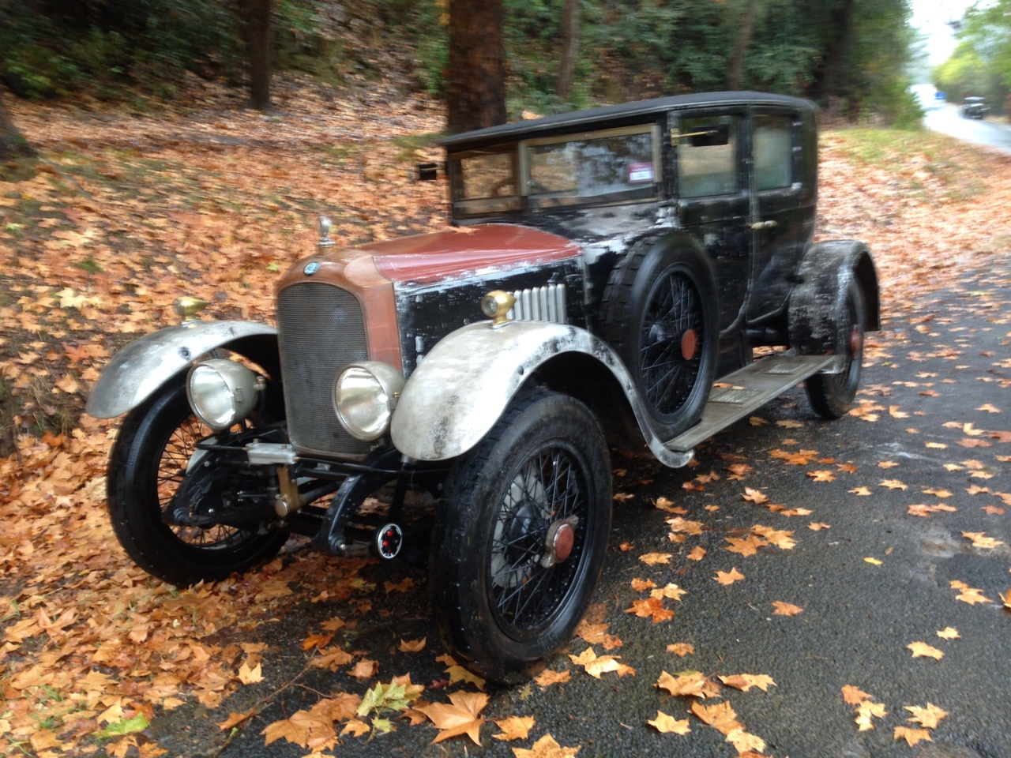
Pat Ryan’s 23-60 Saloon amongst autumn leaves at Jingellic
The end of rally dinner that night was held in the function room of the Resort and included presentation of two hard luck trophies for a car hitting a kangarooo as well as some Penrite products donated for the event. Following the dinner we returned to our rooms to find that it was still raining.
The following morning we all had an early breakfast and said our goodbyes to everyone and the Waltons, Coutts, Mertons, Haywards as well as Mary and I had arranged a two day drive home up through the high country to Cabramurra and Kiandra to overnight in Cooma. We set off from the resort in rain and it did not let up all the way to Corryong where we fuelled up prior to the climb to Cabramurra. At the turn off near Khancoban an illuminated road sign warned of road works and to expect two hour delays so it was decided to take the longer route to Cooma through Thredbo and Jindabyne. It rained all the way to Thredbo with dense fog making the narrow road very difficult to maintain any sort of speed as visibility was very limited. It was cold and wet all the way and as passed through an area aptly named Siberia we noticed two council workers sitting in their truck having lunch, obviously with the heater going inside the cab, a luxury we were without in our Vauxhalls.
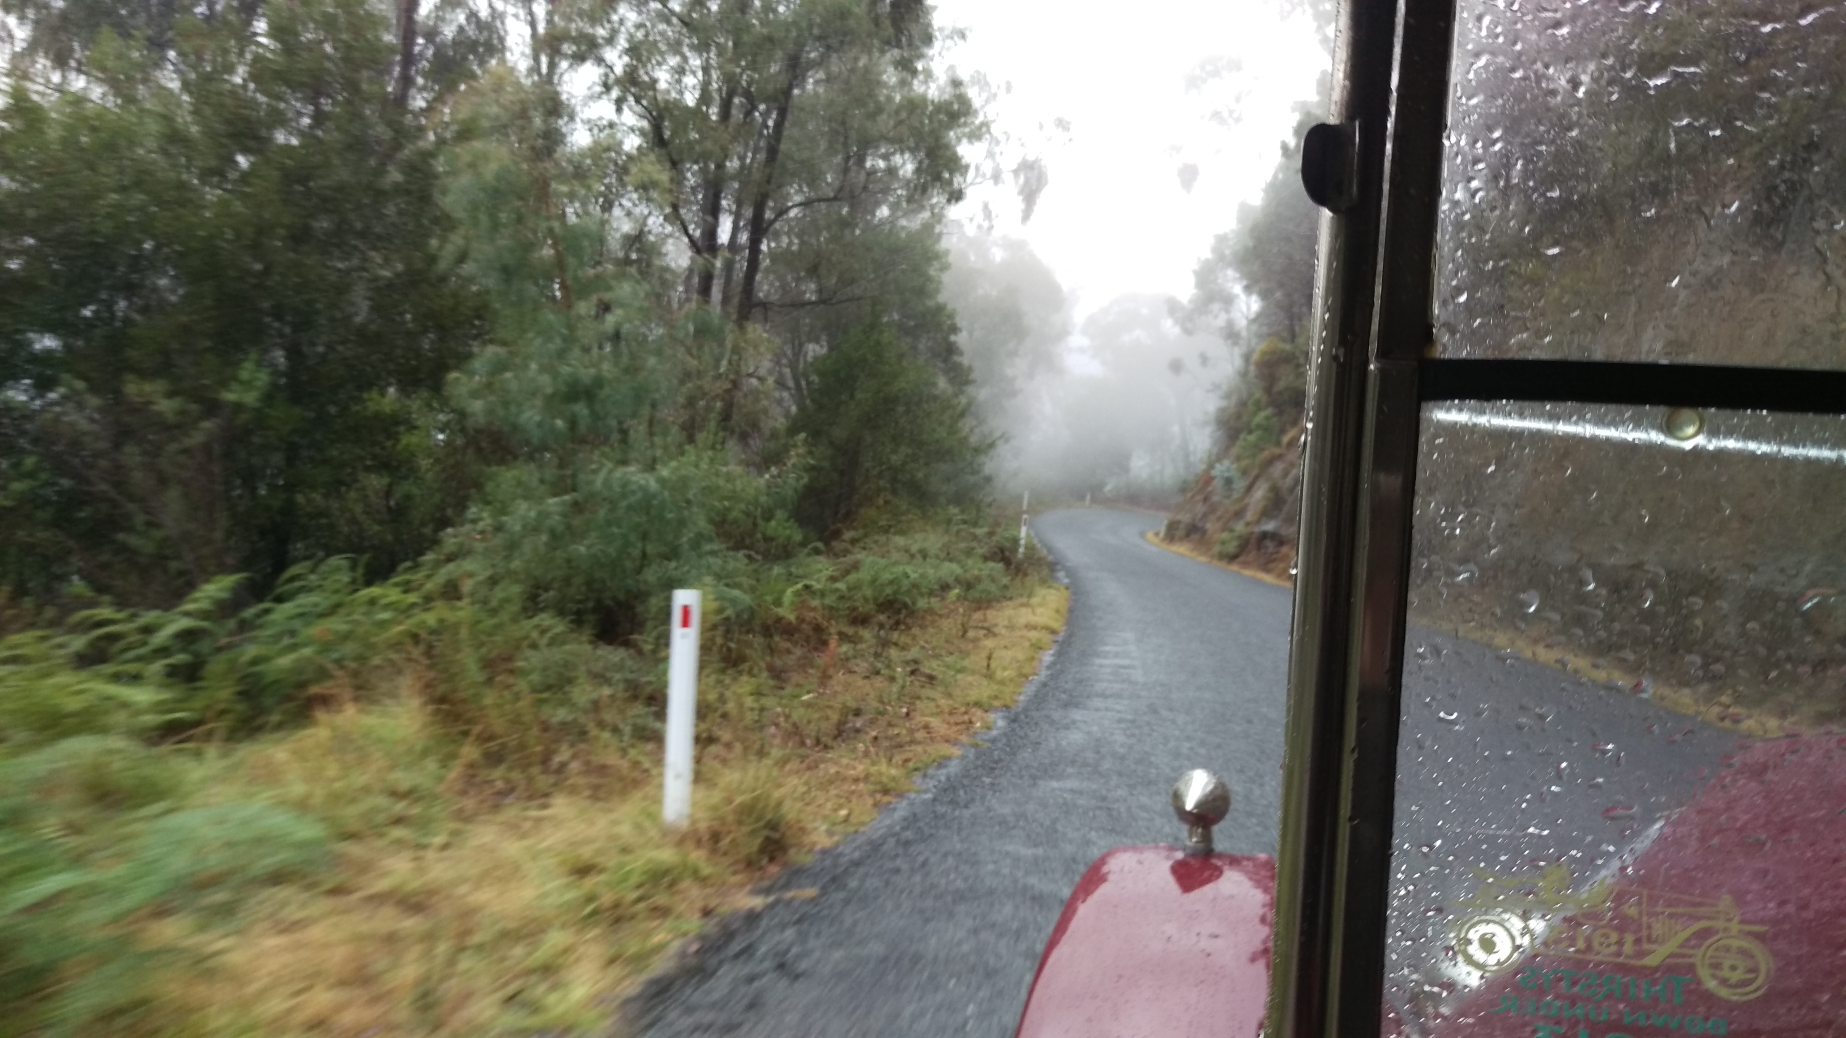
The fog clears a little between Khancoban and Thredbo
We lunched in Thredbo and continued on into Jindabyne into clearing weather to re-fuel and the girl at the service station said it had been sunny all day. So with the sun out again we had a pleasant drive from Jindabyne through Berridale and into Cooma where we all enjoyed a hot shower, happy hour and great dinner in the restaurant of the motel.
The following morning it was clear and sunny, so down went the hoods and off we set to catch up to Richard and Emi Walton who had left a little earlier however run out of fuel near Michelago. There was no sign of them along the road as we approached Michelago, so all was good and we continued on through Queanbeyan to an Olive Farm near Collector where we had lunch. The rain and wind returned whilst we were having lunch, so off again in the rain still with the hoods down and little visibility until it cleared as we approached Goulburn. The final leg into Sydney was in blue sky and sunshine and we arrived home about 5pm tired and hungry. The 23-60 was unloaded and placed in the garage still covered with six days of road grime and had used no oil or water in the 1069 miles we had travelled. I did have a little trouble with the magneto shorting on the Saturday morning at Hume Weir however this problem was overcome with some insulation tape around the connection where number four spark plug lead attaches to the distributor cap. Otherwise the 23-60 like all the other Vauxhalls from Sydney finished without experiencing any major problems.
It was a credit to Peter Weir who took his 1909 A Type Vauxhall A 09.1 and on the Saturday completed the 200 mile journey with his father Jim

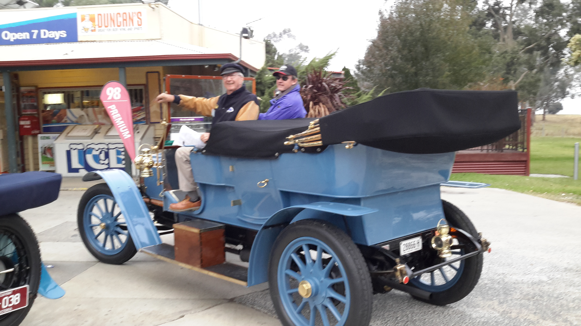
Jim and Peter Weir arrive at Bonegilla for fuel
to Bright and Beechworth returning to the Hume Weir Resort. Believe me this would have been a long drive in the veteran which is obviously not as quick at the other cars being of 3 litre engine capacity, but never the less they completed the same route and travelled the same number of miles as the other cars. For their effort they were each rewarded with a nice bottle of red wine during the presentations at the dinner on the Sunday night, it also served as Jim’s (83) birthday gift for the following day.
Our thanks must go to the organisers of this our first of what will now be regular biannual events for the Vauxhall Register, Justin Coxhead and John Kent both of Victoria who were responsible for putting the event together. It was two years in the making and I am sure they are both very happy with the response the Vauxhall contingent gave and the way the event unfolded.
All reports I have heard since the event have indicated everyone enjoyed the weekend and they are now looking forward to the next Vauxhall Register Rally to be held in Merimbula on the far south coast of N.S.W. in the Autumn of 2018.

