A – D Vauxhall Register
April 2017 Australian NZ Newsletter

Hello Everyone.

I am sending this newsletter out as an attachment to an email and hope that it may overcome some difficulties some members have had, who in the past have had my emails rejected as they have restricted data capacity on incoming emails

Firstly can I advise that it is now less than 12 months to the National Vauxhall Register Rally in Merimbula on the south coast of N.S.W. (Friday 6th to Monday 9th April 2018). I have secured a motel in Merimbula with 48 rooms and at this stage we have some 59 expressions of interest .

EXPRESSIONS OF INTEREST | STATE | CAR
BARGES Ian and Jade | A.C.T. | 23-60
BURNHAM Graeme and Celia | Vict. | 14-40
CANNON Andrew | Vict. | 30-98
CAPIL Ron | Qld. | R Type  20-60
CLARKE Daniel and Louise | Vict. | 23-60
COBURN Peter | Vict. | 30-98
COLLINS Peter | Tas. | 23-60
COUTTS Euan and Wilga | N.S.W. | 23-60
COX George | Vict. | 23-60
COXHEAD Justin | Vict. | E Type
EVANS Dave | S.A. | 14-40
FARRELL Glyn | Vict. | 30-98
FRASER Tim | Vict. | 23-60
GARRETT Adrian | N.Z. | 30-98
GHOSH Julian | UK | 30-98
HANSTED Warrick | Vict. | 23-60
HARDMAN Des and Helen | Qld. | 23-60
HAYES Andrew | S.A. | Prince Henry
HAYWARD Alex | Qld. | 23-60
HEILBRUNN Neil and Maria | N.S.W. | E Type
HENDERSON Rodney and Marie | N.S.W. | 30-98
HIPKINS Mike and Lou | Vict. | 30-98
HIRONS Vyvian | Vict. | 30-98
HOCKING Lloyd | Vict. | 30-98
HOLBEACH Peter | Vict. | 30-98
HOOD Geoff | Vict. | E Type
HOUSE Ron and Judy | Vict. | 30-98
KEIL Chris | Vict. | 30-98
KENNEDY Peter | S.A. | D Type
KENT John and Wendy | Vict. | 30-98
KENWOOD Michael | Qld. | D Type
KIRK Dave | UK | 23-60
LATREILLE Peter and Ann | Vict. | 30-98
LEAR David | Qld. | D Type
LOVELL Robert and Meryl | N.S.W. | 23-60
McDONOGH Murray | A.C.T. | Bristol
McMURRAY Ross and Anne | N.S.W. | 14-40
McNAUGHTON Ian and Libby | Vict. | 30-98
MERTON Wayne and Olwyn | N.S.W. | D Type
MORRIS Barry | Qld. | 23-60
NICHOLSON Vic and Warwick | N.S.W. | 30-98
O'DOHERTY Damian and Vicki | Vict. | 30-98
PATTON Ian and Jenny | NZ | 23-60
RHOOK Reg and Jean | Vict. | 23-60
RICKARD Gary and Carol | N.S.W. | 23-60
ROBERTS Greg and Gill | N.S.W. | D Type
ROBSON Rob and Lyn | Qld. | D Type
RYAN Pat | Vict. | 30-98
STUART David and Mary | N.S.W. | 23-60
TAYLOR Jeff and Mary | Qld. | Modern
TEMPLER Peter and Chris | S.A. | 14-40
VINALL David | S.A. | 30-98
VIRGONA Phil and Tracey | N.S.W. | 23-60
WALTON Richard and Emi | N.S.W. | 30-98
WARD Peter and Margaret | N.S.W. | 23-60
WEGENER Robert | Qld. | 23-60
WEIR Peter | N.S.W. | D Type
WEIR Jim and David | N.S.W. | 30-98
WHITFIELD Leigh | Vict. | 14-40

If you now find you can attend the event and your name does not appear on the expression of interest list please either contact me by email or phone to have your name included. Those whose names appear on the expression of interest list and now find they are unable to make the rally, to confirm this with me also by way of email or phone call.

I expect some fall out of names from the list of expressions of interest once the entry forms go out however if we do exceed the 48 entries then there will naturally be an overflow of entrants accommodation into a second motel.
Mary and I are attending a V.S.C.C.A. Autumn Tour at the end of this month and we actually stay for one night in Merimbula so I will check out our motel to secure an accommodation costs. I understand there are three standards of rooms and each priced accordingly. If I am happy with the standard of the accommodation I will confirm our booking, so once the entries go out the room rates will be on the entry form and you will need to indicate the standard of room you prefer. These will be allocated as the confirmed entries are received by me and if the room level you request has filled up then you will automatically be allocated the next standard of room. This will also encourage you to get your entries in early to secure the accommodation you require as once the motel fills then entrants will be booked into the second motel. I would expect to send the entry forms out in early May and you will be required to include payment of the entry fee to the rally.

We have retained the entry fee to the rally at $80.00 per couple and you will be requested to make this payment with your entry form. The entry form can be returned to me by email or by post to the addresses at the bottom of this newsletter. Please be prompt with lodging you entry forms to me together with your entry fee and this will help allocate the accommodation you require. The entry form will also provide you with the opportunity of indicating to me that you would prefer to find your own accommodation.

Shortly after I receive your confirmed entry I will notify you of your accommodation details and you will be requested to make contact with the motel you are booked into and provide them with your payment details.

More later about the rally in the early part of May.

As some may have heard, Peter Weir (A.09.1) from Wongawilli south of Sydney has just purchased the D Type Vauxhall D3120, photo attached, from John

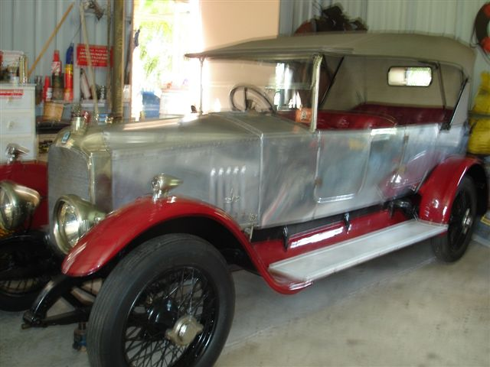

Hecker in Maryborough Queensland and hopefully will have the car home the week after easter. I will include a report on the car in a following newsletter however can say that Peter intends bringing the D Type to the rally in Merimbula and his brother David and father Jim will bring their 30-98 OE169.

John Link from Victoria has his 23-60 OD797 (photo attached) for sale and contact can be made direct with John for information on this vehicle. The car was built up by Stan Coath V.S.C.C. Victoria many years ago and Stan built it along similar lines to a Lagonda M45R which he really wanted to buy at the time however could not afford one. I have attached a photograph of the car with Stan Coath standing beside it displaying trophies, as it was in his day. It passed on through Barry Ponchard also of Victoria before coming into John's

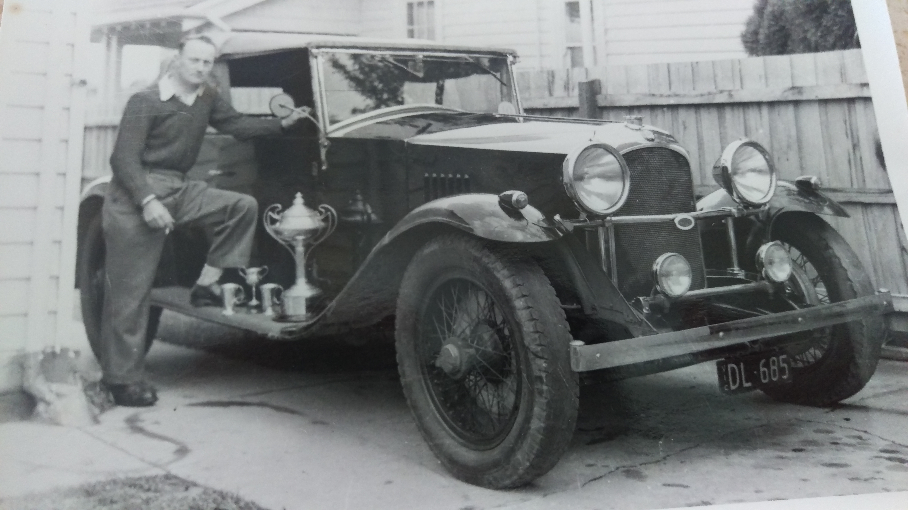ownership where he has spent a considerable amount of money refurbishing the car.
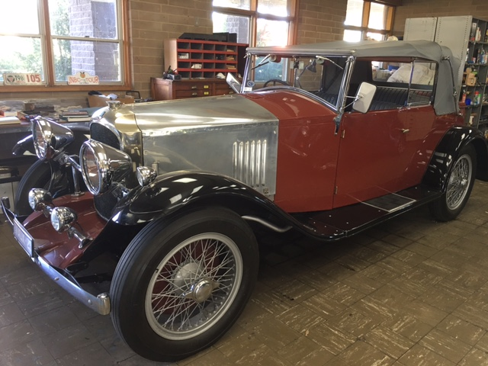

At the present time the original engine OD779 is out of the car being rebuilt however it is presently fitted with a Holden engine to keep the car on the road during the rebuild. Contact with John can be made on mob: 04 1936 1237.

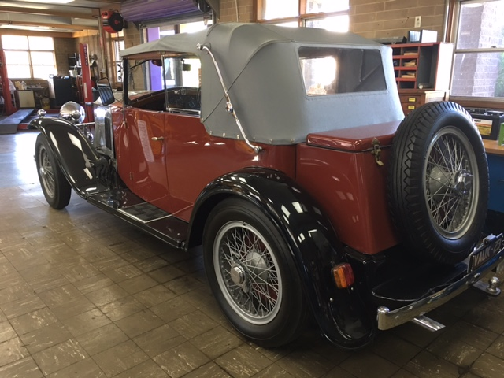

News also received today that OD387 (Photo attached) sold at auction in England for UK65,000 which equates to nearly double what it would have brought out here in Australia.

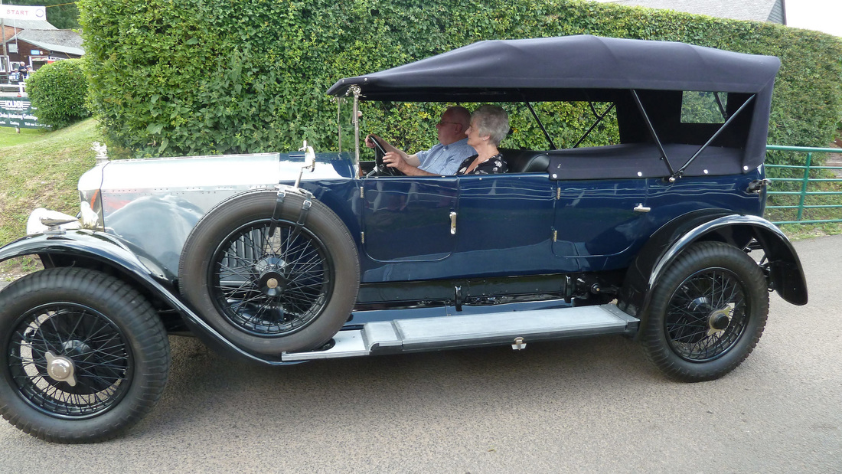

Not much more news at this stage however letting you know we now have included the NZ members of the A - D Vauxhall Register in our mailouts. This particular newsletter also includes 30-98 members as well, as there is news of the coming 2018 Vauxhall Rally included, normally our newsletters would only go to those members of the A - D Vauxhall Register. I believe Peter Latreille is working on an Australian website for the 30-98 Register as well as a national mail out to owners of 30-98's in Australia in order for them to be updated with thirsty matters.

In future newsletters I will include a Vauxhall related photograph/s either depicting a present or past Vauxhalls or even their owners. This month’s photographs are of a Vauxhall owner on his wedding day in 1965 as well as two of his cars in various stages of repair in the backyard of his home...a) who is he, b)what are the car numbers, c)do they still exist and finally c) where are they now located?

Email me your answers and I will announce the prize winner with all the correct answers in the next newsletter.

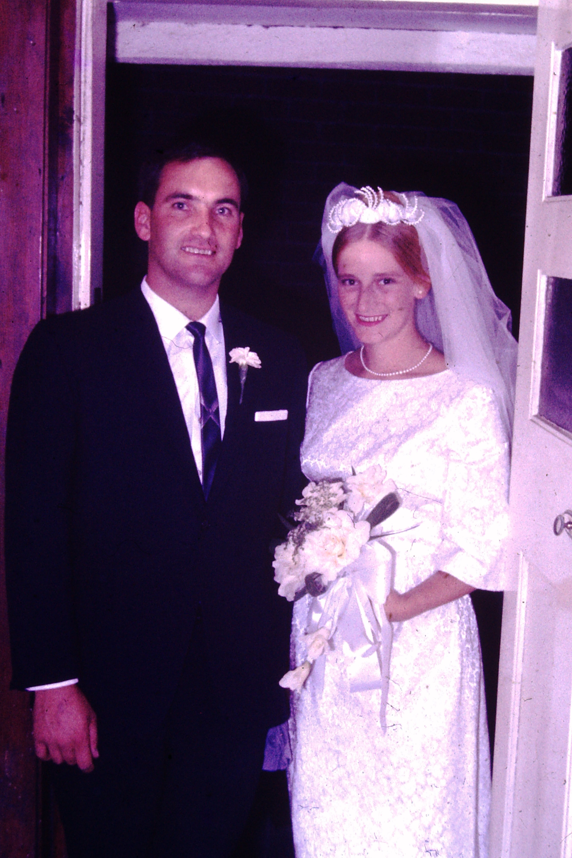
I acknowledge answering some of these questions may present a problem for those living across the ditch, so maybe one of you over there might send me some photos to use to even things up.

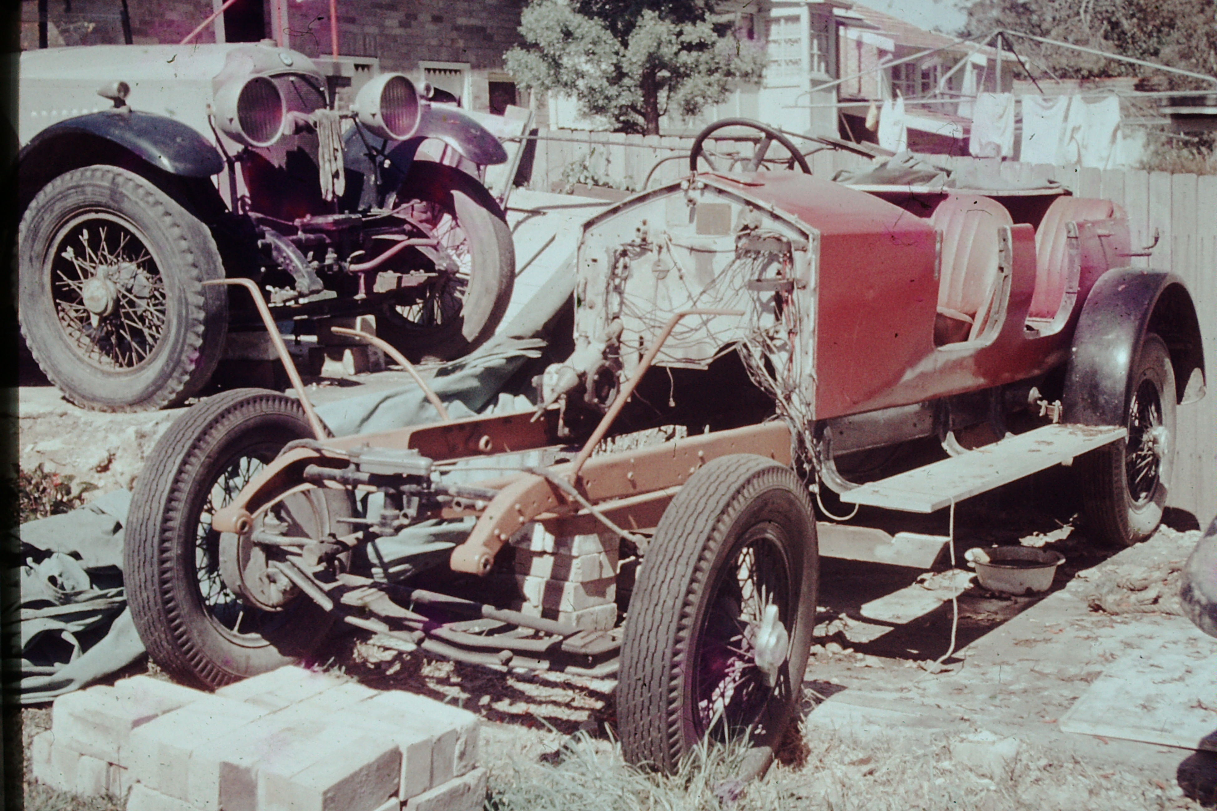

That's all for now, I will send out another email re the 2018 rally when I return from the Autumn Tour in early May

Dave Stuart.
mob: 04 2828 2360
Email: tubby2360@gmail.com

