THE VINTAGE SPORTS CAR OF AUSTRALIA
2016 GEORGE GREEN MEMORIAL RALLY
(With some Vauxhall bias)

This major Club event was run from Thursday 13th to Tuesday 18th October with the start following lunch at the Wentworth Falls Golf Club west of Sydney in the Blue Mountains.

Vauxhalls entered were:-

Peter and David Weir in 30-98 OE 169
Richard and Emi Walton in 30-98 OE53
Euan and Wilga Coutts in 23-60 OD793
Peter and Margaret Ward in 23-60 OD1107
Alex, Rosy, Orlando and Peter Hayward in 23-60 OD1303
David and Mary Stuart in 23-60 OD494

Sixty or so cars headed off up the Great Western Highway through Katoomba and Hartley to Lithgow where we turned off for a quieter road to Bathurst via Tarana. The die hards stopped in at the Tarana Hotel for a comfort stop as well as to settle the dust. Even the girls partook in some dust settling Baileys Irish Cream to warm their hearts and prepare them for the cooler final run into Bathurst, being over overnight stop.

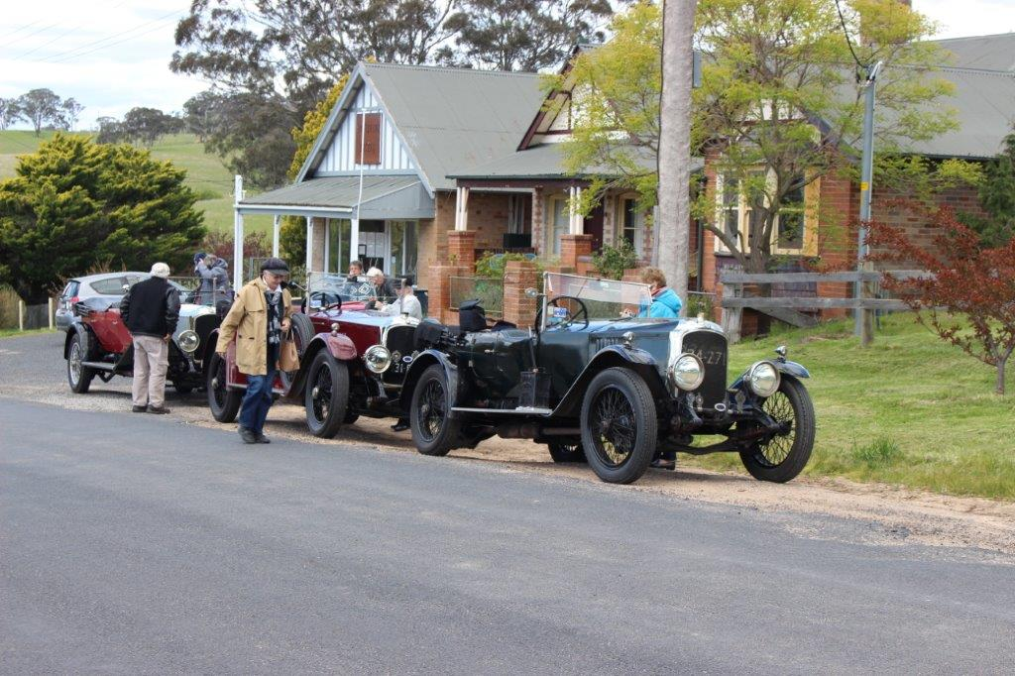
OE53 – OD494 and OD793 at Tarana

The run from Tarana to Bathurst took us through O’Connell and the countryside was picture perfect with the paddocks and hills so green indicating the farmers were in for a good season. At Bathurst once the cars were bedded down it was off to the local R.S.L. Club for the happy hour and dinner. Following dinner we enjoyed a nice walk back to the motel and all enjoyed a good night’s sleep following our first day on the road. All Vauxhalls running well and no problems experienced.

Friday saw us head off towards Orange via the picturesque Ophir Road, being narrow, winding and most pleasant for the Vauxhalls. We had travelled this road on previous rallys and it sure sure it beats travelling on the highway fighting with the B Doubles and grinding your way along with all the moderns. This road is most suited for our cars and we travelled at a pace where the view of the surrounding picturesque countryside could be enjoyed.
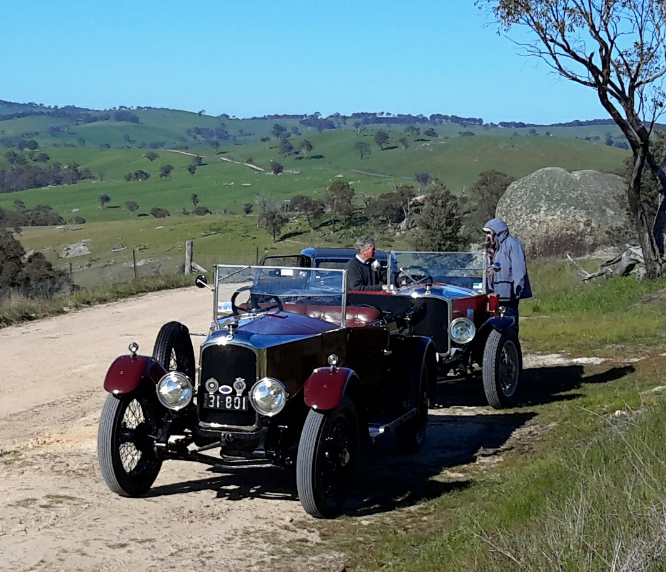
OD494 and OD793 at the lookout on the Ophir Road

Arriving in Orange about 10am we all enjoyed the organised morning tea in the cafe at the Botanical Gardens before a few of the cars headed off for the Clergate Primary School to show the girls and boys our cars. Lined up outside the school the

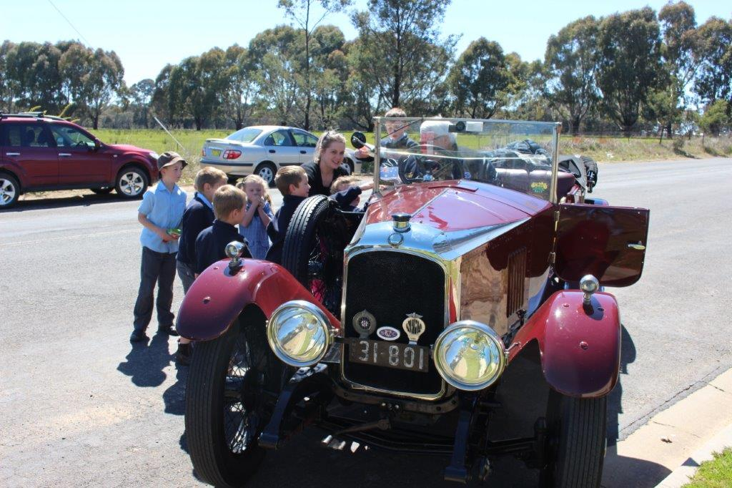
Pupils inspect OD494 at Clergate Primary School

cars were poured over by the children taking it in turns to sit in the driver’s seat as well as a lot of klaxon horn blowing took place. Their whole twenty minute recess was taken up before the bell rang for them to return to their classes. It was nice to show the children the cars and I am sure some of them didn’t know the old cars could be so much fun.

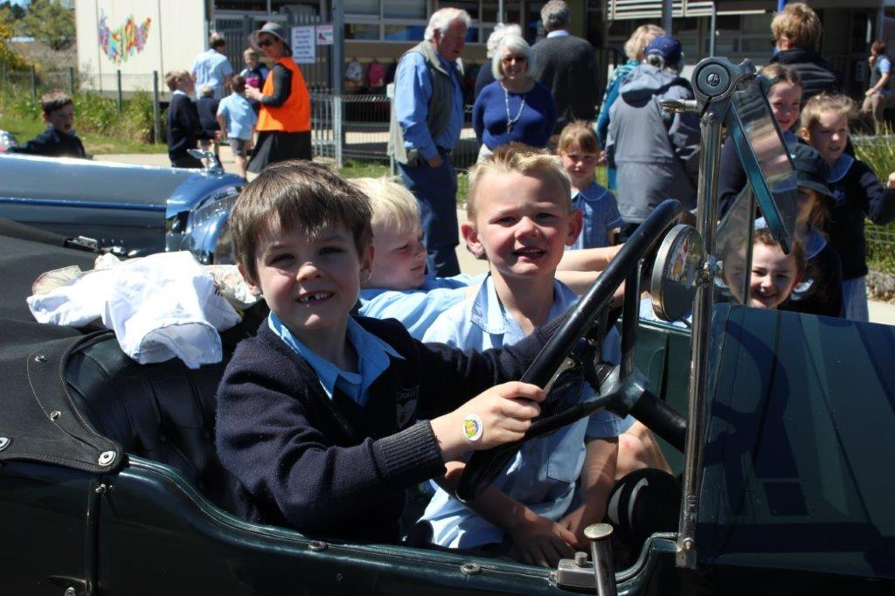
Pupil ready to take OE53 for a run with his mates

Leaving the school we rejoined the rally route and travelled via Euchareena to Stuart Town where we found some of the entrants stopped for a break and cool drink.

We turned off here to head over to Wellington and join the rest of the entrants for lunch at the Wellington Caves.

The lunch at the Caves was prepared by the local country ladies and we were all provided with a nice ham or chicken salad with lashings of home made cakes and coffee. Following lunch we took the optional quieter route to Dubbo which took us again through lovely countryside on sealed roads with very little traffic and the occasional abuse from a blue healer on the back of a passing farmer’s ute. On booking into our motel in Dubbo it was off again to the happy hour and dinner at the motel. As we were booked in here for three nights our 23-60 was unloaded and I am sure if you could see the amount of gear our navigators must take with them these days, obviously the car breathed a sigh of relief.

Saturday morning we drove to the Lazy River Estate Winery come reception centre which is situated alongside the Macquarie River. Tables and chairs were set up on

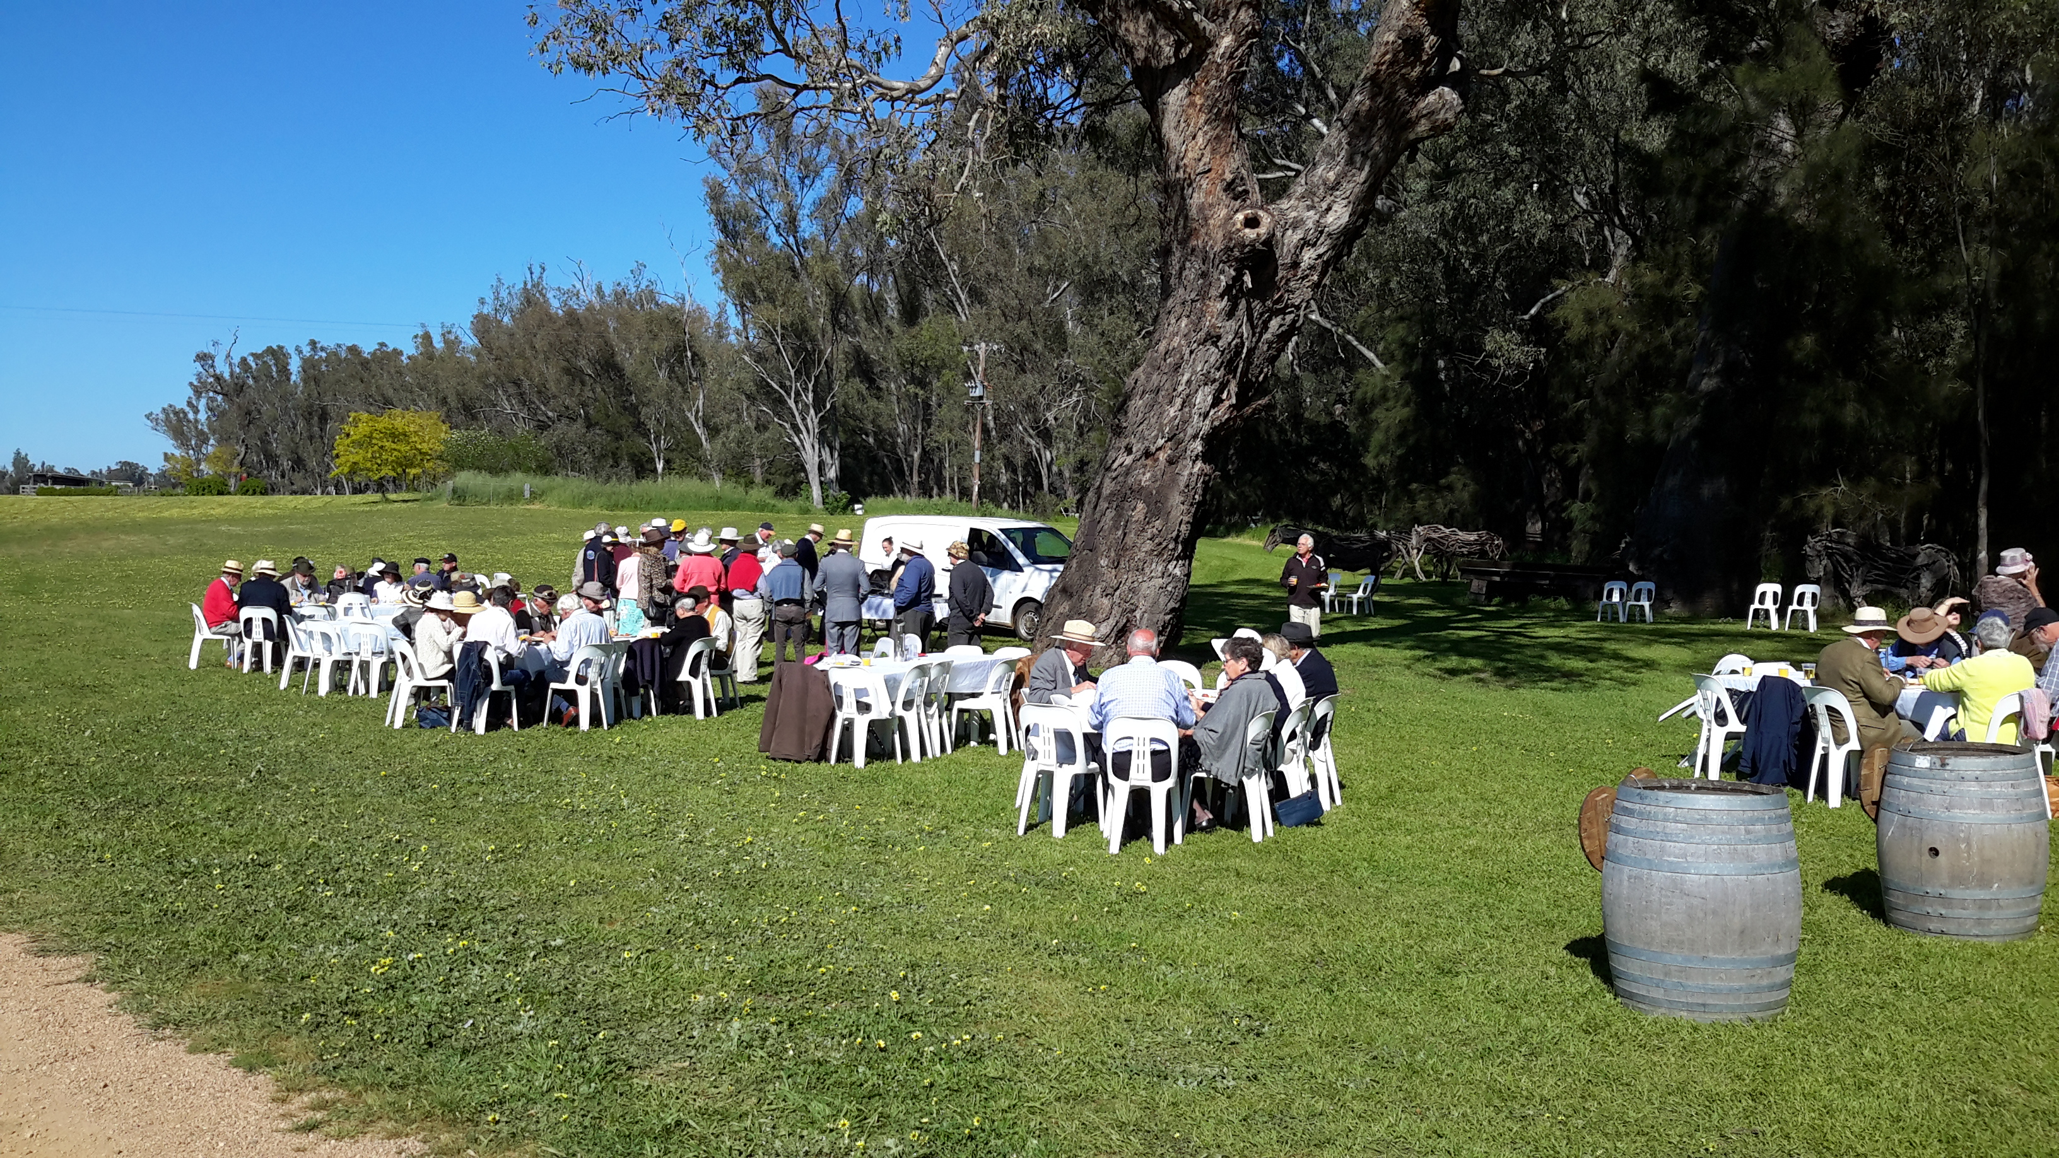
Breakfast beside the Macquarie River

the grassed area beside the river and this is where we had breakfast. Nicely prepared bacon and eggs, orange juice and coffee was enjoyed by all those who attended and we also met the members of the local vintage car club who were waiting at the entrance to the winery in their cars when we arrived. Following breakfast we returned to the cars and then it was back into town and off to Narromine Turf Club for their picnic race day.

We drove to Narromine via the main highway and on arrival we were booked in for a visit to the local aircraft museum which proved well worth our stop. We were provided with a guide who gave the most interesting talk on the history and development of the Museum as well as a potted history of the local pilots from the

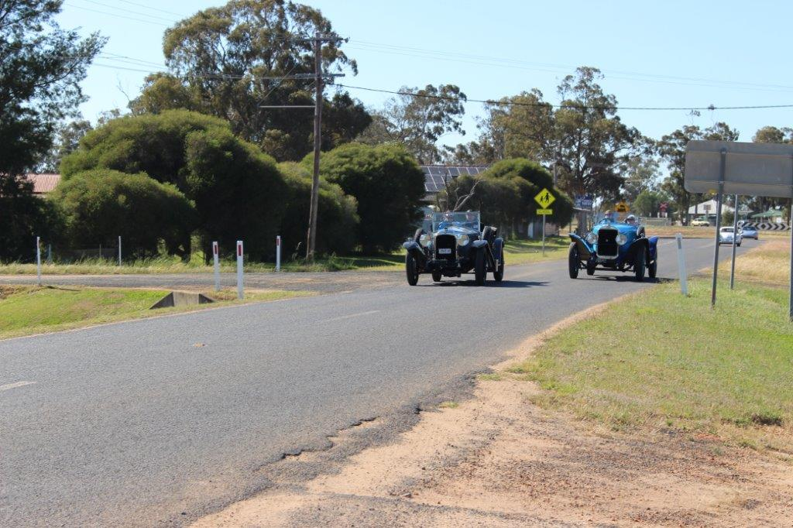
OE 169 overtakes a 20/60 Sunbeam in Narromine

Narromine district who undertook their elementary training at the airfield. The museum and its display is a credit to the locals and was well worth the hour we spent there.

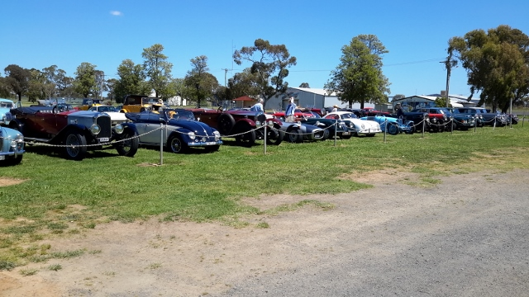
A variety of Club cars parked at the Narromine Air Museum

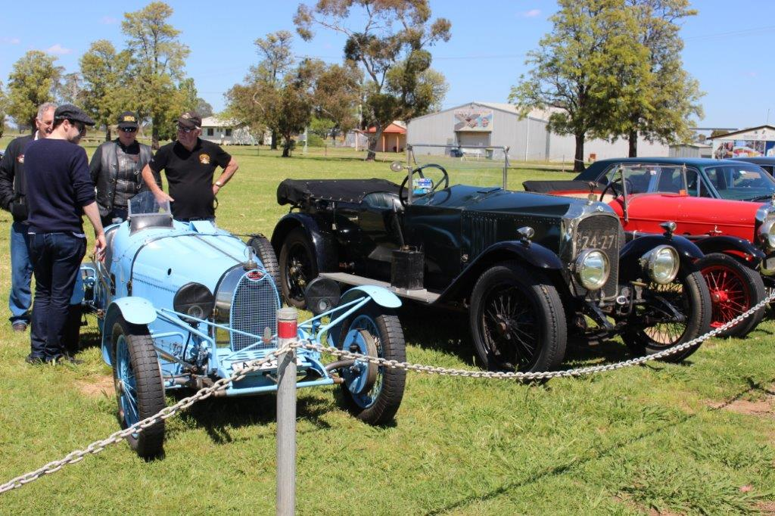
OE53 flanked by a Bugatti 37A and Alvis 12/50

Following our visit to the museum it was back into the cars and a ten minute drive to the Narromine Turf Club were our Club was the special guest on the day. Cars were provided with priority parking right beside the race track and our tables were set up on the lovely grassed area also beside the track boarded by colourful rose garden in full bloom. Would you believe our Vauxhall group scored the table right beside the bar area, you see good things happen to good people.

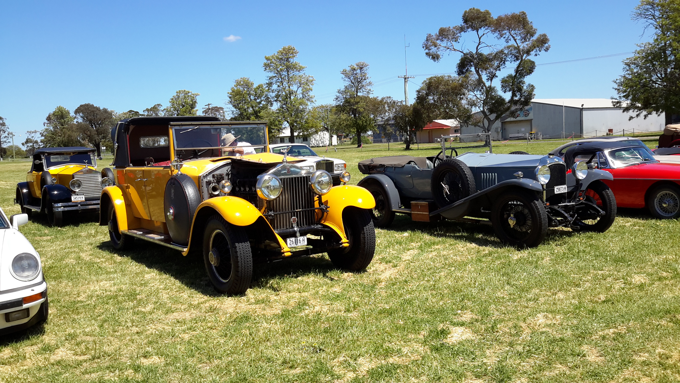
OE169 at the Narromine Turf Club beside P1 RR called Pumpkin
The races provided great entertainment even for those not interested in betting. Our first drink was provided free and the finger food just kept on coming. A lot of our members were betting on the races, some of the ladies fancying the colours of the jockeys silks and other purely on the name of the horse. Not much form came into the equation and I should imagine the bookies did not do too well from our $2.00 bets.....though Meg Lewis did lash out with a ten dollar bet to see her horse come in second at long odds....however she only backed it for a win.

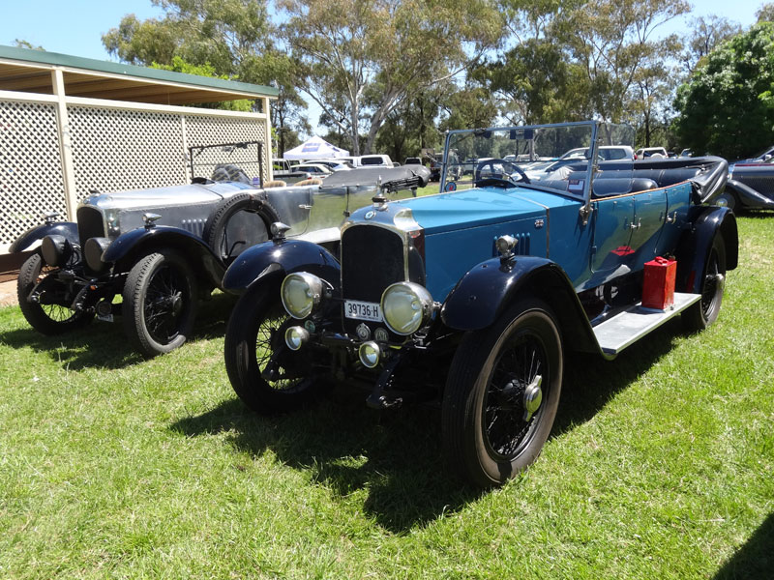
OD1107 and OD1303 at the Narromine Turf Club

Following the running of the Vintage Sports Car Club invitation race, named in our honour, a lot of us departed for the return run back to our Motel in Dubbo. That night we were bussed to the restaurant at the Dubbo Zoo where following dinner some prizes were awarded as well as the announcement of another six day Club touring event in the Autumn of 2017. Following dinner it was back to bed in preparation for our run the following day to a working sheep station.

Sunday took us on a back road north from Dubbo to Gilgandra and at the town centre we were provided with morning tea by the local CWA ladies. All the home bakes you could imagine were available for our consumption which I am happy to report our Club members are so good at. This was followed by a short drive to the local information centre where there is a world class display recording the history of

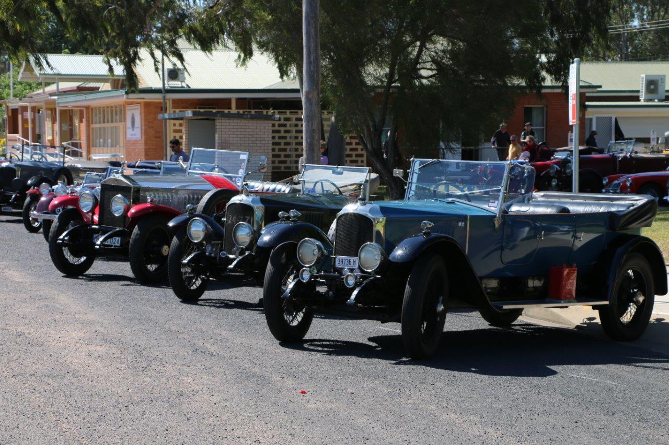
OD1303 and OE53 with a Rolls Royce and OD1107 in Gilgandra

Gilgandra and its surrounding towns. Again a credit for such a wonderful presentation being provided by such a small country N.S.W. town.

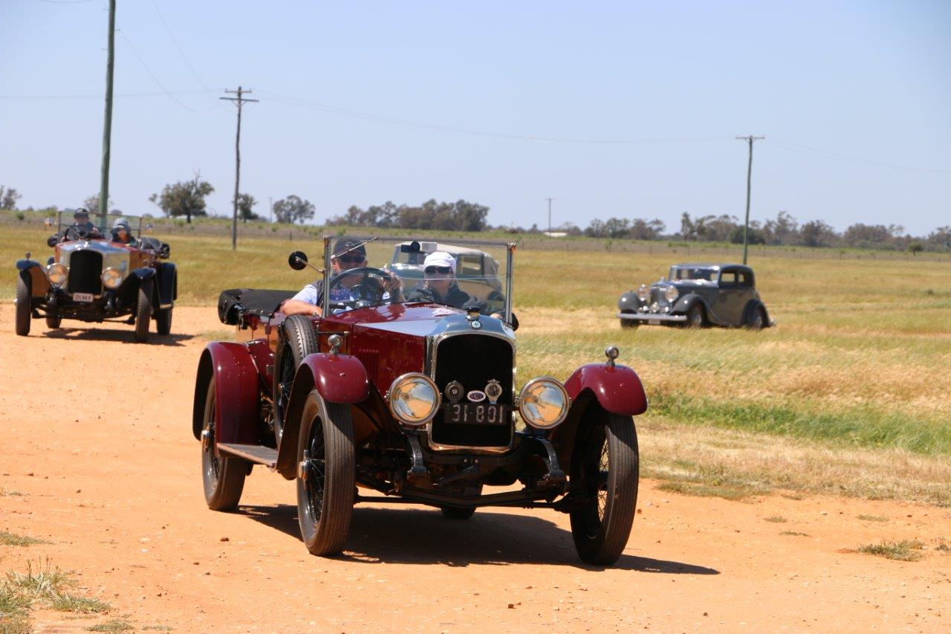
OD494 and OD793 and two Derby Bentleys arriving at Berida Woolshed

This was followed by a twenty minute drive to Berida Station, a local property which in the early 1800’s boasted some 160,000 acres of cattle and sheep. It was divided
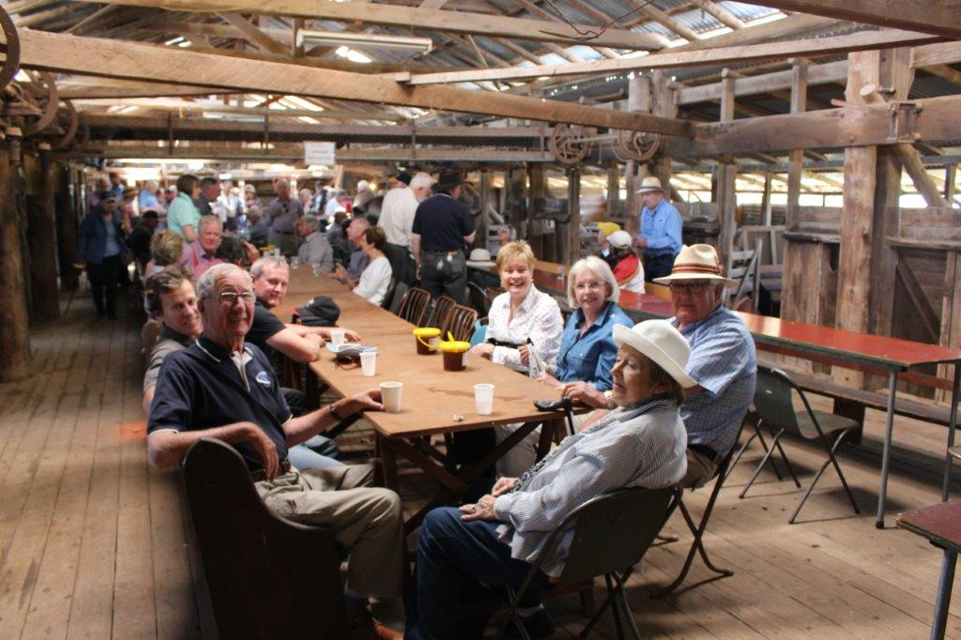
Lunch in the wool shed at Berida

in half by the government in the late 1800’s to 80,000 acres and further broken up into soldier settlement farms for the returning servicemen at the end of world war one.

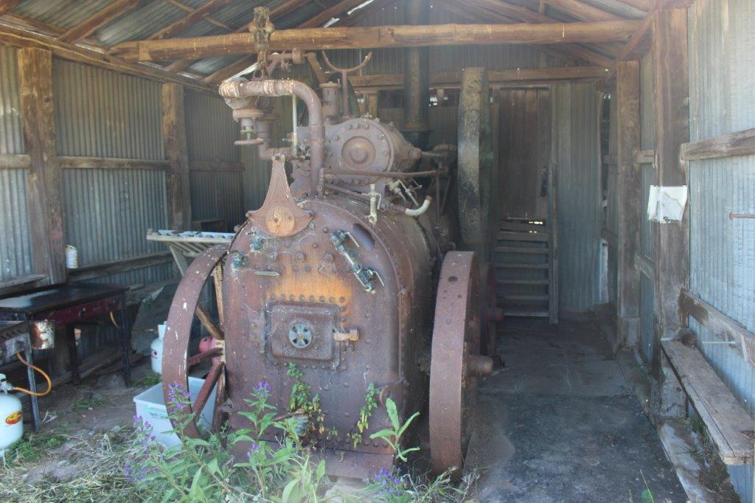
Original power plant for the wool shed

It was a kilometre drive from the front gate to the ten stand sheering shed where we were to have lunch. Lunch was barbecued locally produced lamb sausages with salad and home baked bread.

This was followed by cakes and coffee as well as a talk by the owner of the property on Berida history and present day running of the sheep and cattle. The shearing shed is the largest in the district and has ten shearing stands originally powered by a steam engine which is still standing in its purpose built shed attached to the shearing shed. Today there are only four stands working and these are now powered by electric motors for each stand. We were given a demonstration of hand shearing as well as a complete clip taken from a sheep with modern wide comb electric shears. Shortly after we left Berida for our return journey back to Dubbo which was to take us through Collie.

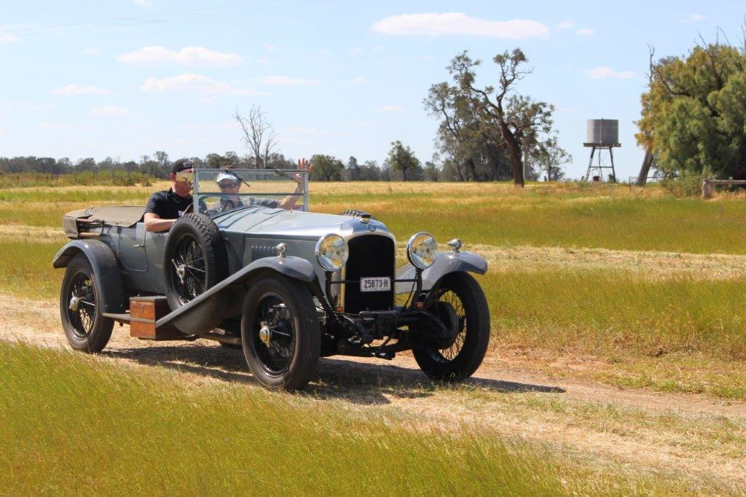
OE169 leaving Berida woolshed

Sunday night was the final dinner where all the entrants to the rally would be together. There were formal speeches and our interstate guests were also thanked for participating in the event. No port tonight and straight off to bed.

The following morning (Monday) a group of us in Vauxhalls had a nice breakfast in a cafe in the Dubbo main street which was followed by a short run to the motor body works of Mark Nugent to view his factory. There were many new and old projects underway and it was wonderful to see such fine workmanship by these tradesman. It is in fact world class as they are now receiving many of their new jobs from overseas.

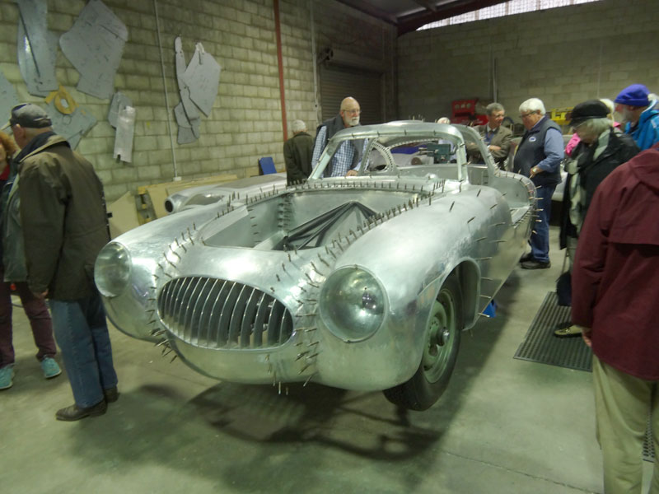
A gull winged Mercedes being created.

We left Dubbo on our homeward journey and headed off in rain for the historic township of Gulgong where in the main street we enjoyed a hot coffee in the local bakery. We meet up with the rest of the entrants at the local Bowling Club for lunch

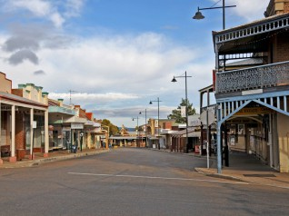
The main street of Gulgong

and then it was off again still in light rain to the even more historic township of Sofala. In Sofala some of the entrants were enjoying some cheer in the one and only pub however following a comfort stop we continued on to Bathurst for our overnight stop. The weather had cleared some what by Sofala and it was back into blue skies and sunshine.

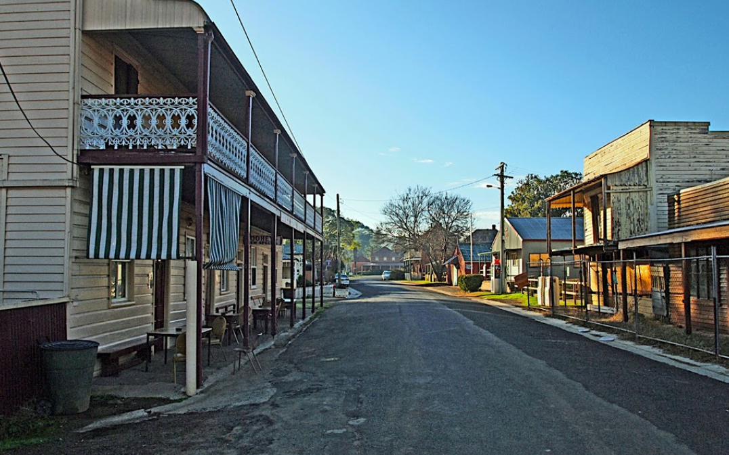
The main street of historic Sofala

We all booked into the same motel in Bathurst and once booked in it was decided to start an early happy hour at the local R.S.L. which was only a short walk. Everyone gravitated to the R.S.L. as it was in the function centre of the club we were to have our final end of rally dinner. Following dinner one medicinal port was allowed by the powers to be before heading off for our rooms for the night.

The following morning saw the weather had cleared completely, the rain was gone, so following breakfast it was down to refuel and head off with Alex and Peter Hayward following us in OD1303 for our final leg into Sydney over the Blue Mountains. We left Bathurst about 9.30am and were home in Sydney about 1pm following a coffee break at Springwood.

In all we had travelled some 730 miles in the six days and all Vauxhalls ran well without any problems. There were a few hiccups with some of the other cars and two were taken home on trailers however I think everyone agreed it was a great six days of vintage motoring, we were in good company and we travelled through some magnificent countryside on our journey.

Dave Stuart.
1 November 2016

