A – D VAUXHALL REGISTER
MAY 2017 NEWSLETTER

Hello Everyone.

I have attached to this newsletter an entry form for the coming National Vauxhall Rally to be held in Merimbula on the south coast of N.S.W. from the 6th to the 9th April 2018. The entry form gives you the opportunity of entering the rally and paying the entry fee of $80.00 as well as indicating what standard of accommodation you prefer. The main motel I have booked has 48 rooms however as we presently have 62 expressions of interest (list attached) in the rally there will be an overflow into a second motel if all expressions of interest turn into entries. As I receive the entry forms I will contact the entrant and provide them with the contact details for the motel and this will be done on a first entries received first allocated basis, so it will encourage you to get your entry to me a.s.a.p. to secure a room in the main motel with the majority of the entrants. Once the main motel fills, the overflow will go into the second motel.

The entry form will also give you the opportunity of indicating if you would prefer commencing the rally from Sydney on Thursday 6th April and overnighting at a motel in Cooma on the way to Merimbula. Similarly you will also get the opportunity of coming home to Sydney together in two days along the coast road with another stop.

John Kent and Justin Coxhead are also getting together a similar package to provide entrants travelling via Victoria to Merimbula and those entrants will have the opportunity to taking two days to and from Merimbula.

So, all to do now is get your entry form into me if you are a starter on the rally, and importantly, please let me know if you have expressed interest in attending however now find that you can’t make it.

Moving on from rally matters. Peter Weir and I recently brought his newly acquired D Type home from Maryborough in Queenland. We towed it home to Sydney on a trailer and it is now being serviced and detailed ready for an open house inspection at Peter’s property in Wongawilli near Dapto south of Sydney on Saturday 13th May. Photo of D3120 attached.

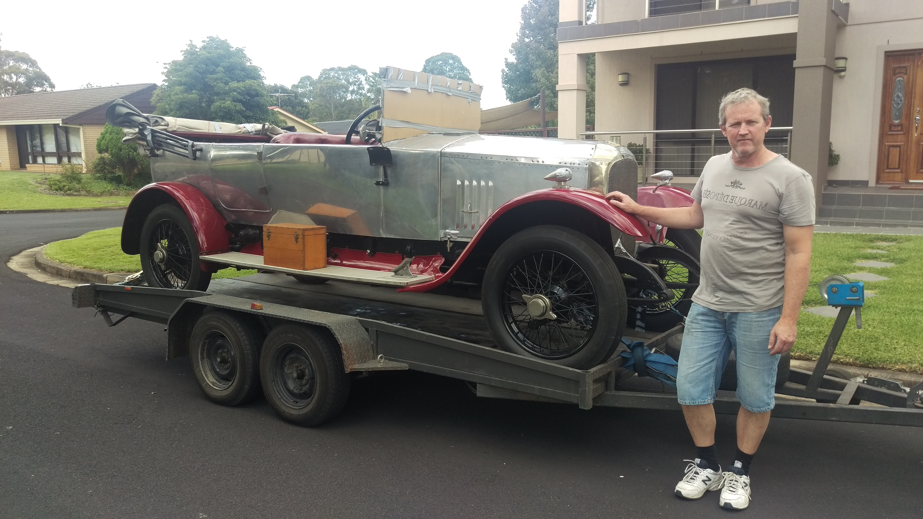

Peter Weir and D3120

For those who attended the National Vauxhall Rally at Hume Weir last year might remember Peter and his dad Jim were in Peter’s A Type A.09.1 and completed both days of the weekend without mishap. Peter intends bring the D Type to the rally in Merimbula and his brother David will be entering with Jim in his 30-98 OE169.

Mary and I recently returned home from the six day Autumn Tour run by the V.S.C.C.A. south to Merimbula, then home through Jindabyne, Tumut and Young.

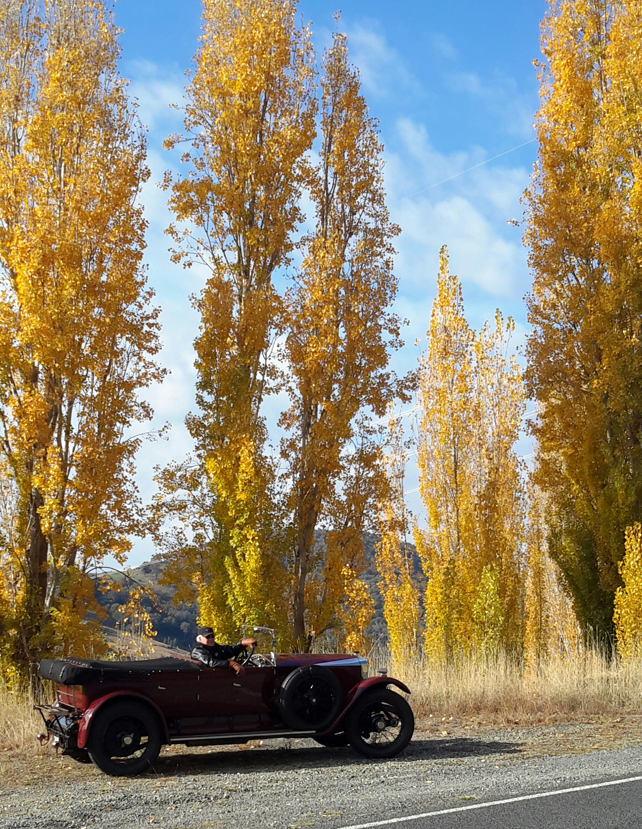

Autumn colours between Tumut and Rosewood

On the way home from our stop in Young our group of Vauxhall enthusiasts stopped in the little village of Rugby (population not many) and met up with William (Bill) Kelly. Bill’s grandfather’s brother Richard (Rich) Kelly had an accident in his new 30-98 in 1926 and suffered life threatening injuries to his chest. He had picked up his three nephews at Frogmore and was driving the 30-98 to Boorowra to truck wethers. He went to overtake a car and clipping it lost control of the 30-98 and it overturned. The nephews received minor injuries and some broken bones however Rich Kelly died the following day in Boorowa Hospital. He is buried in Boorowa Cemetry. Following his trip to Boorowa Rich was to overnight with his mother at her property Lugano in Rugby which is the property Bill Kelly now owns. Rich Kelly owned an adjoining property Riverview and this property is still owned by the Kellys.

Now you are waiting to read about what happened to the car and where is it now. Was it broken up and used as spares? was it returned to Boyd Edkins? or was it languishing in a shed on the property Lugano waiting for someone about my size to discover it? I was thinking of writing this article so as the second part appears in the next newsletter however I knew if I did that I would be bombarded with phone calls from those who could not wait to hear the result. Photo of car & Rich Kelly attached.

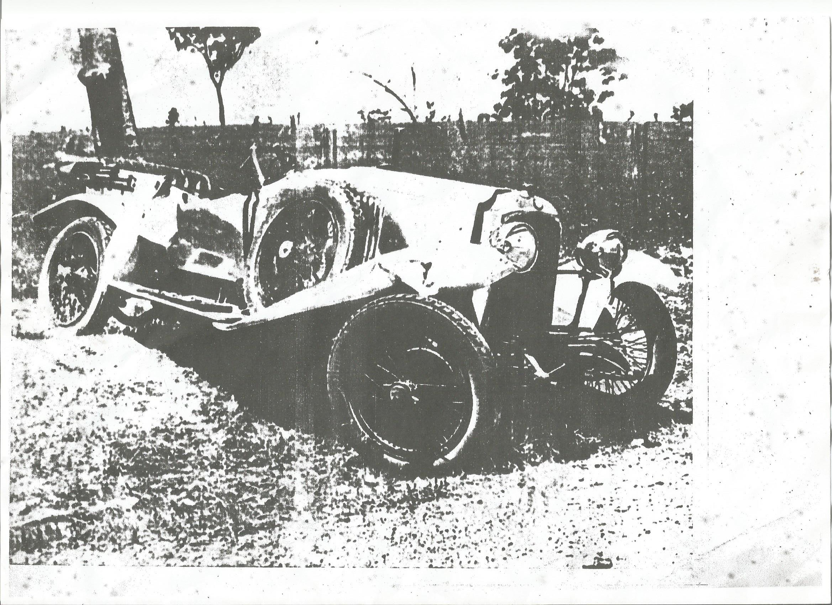

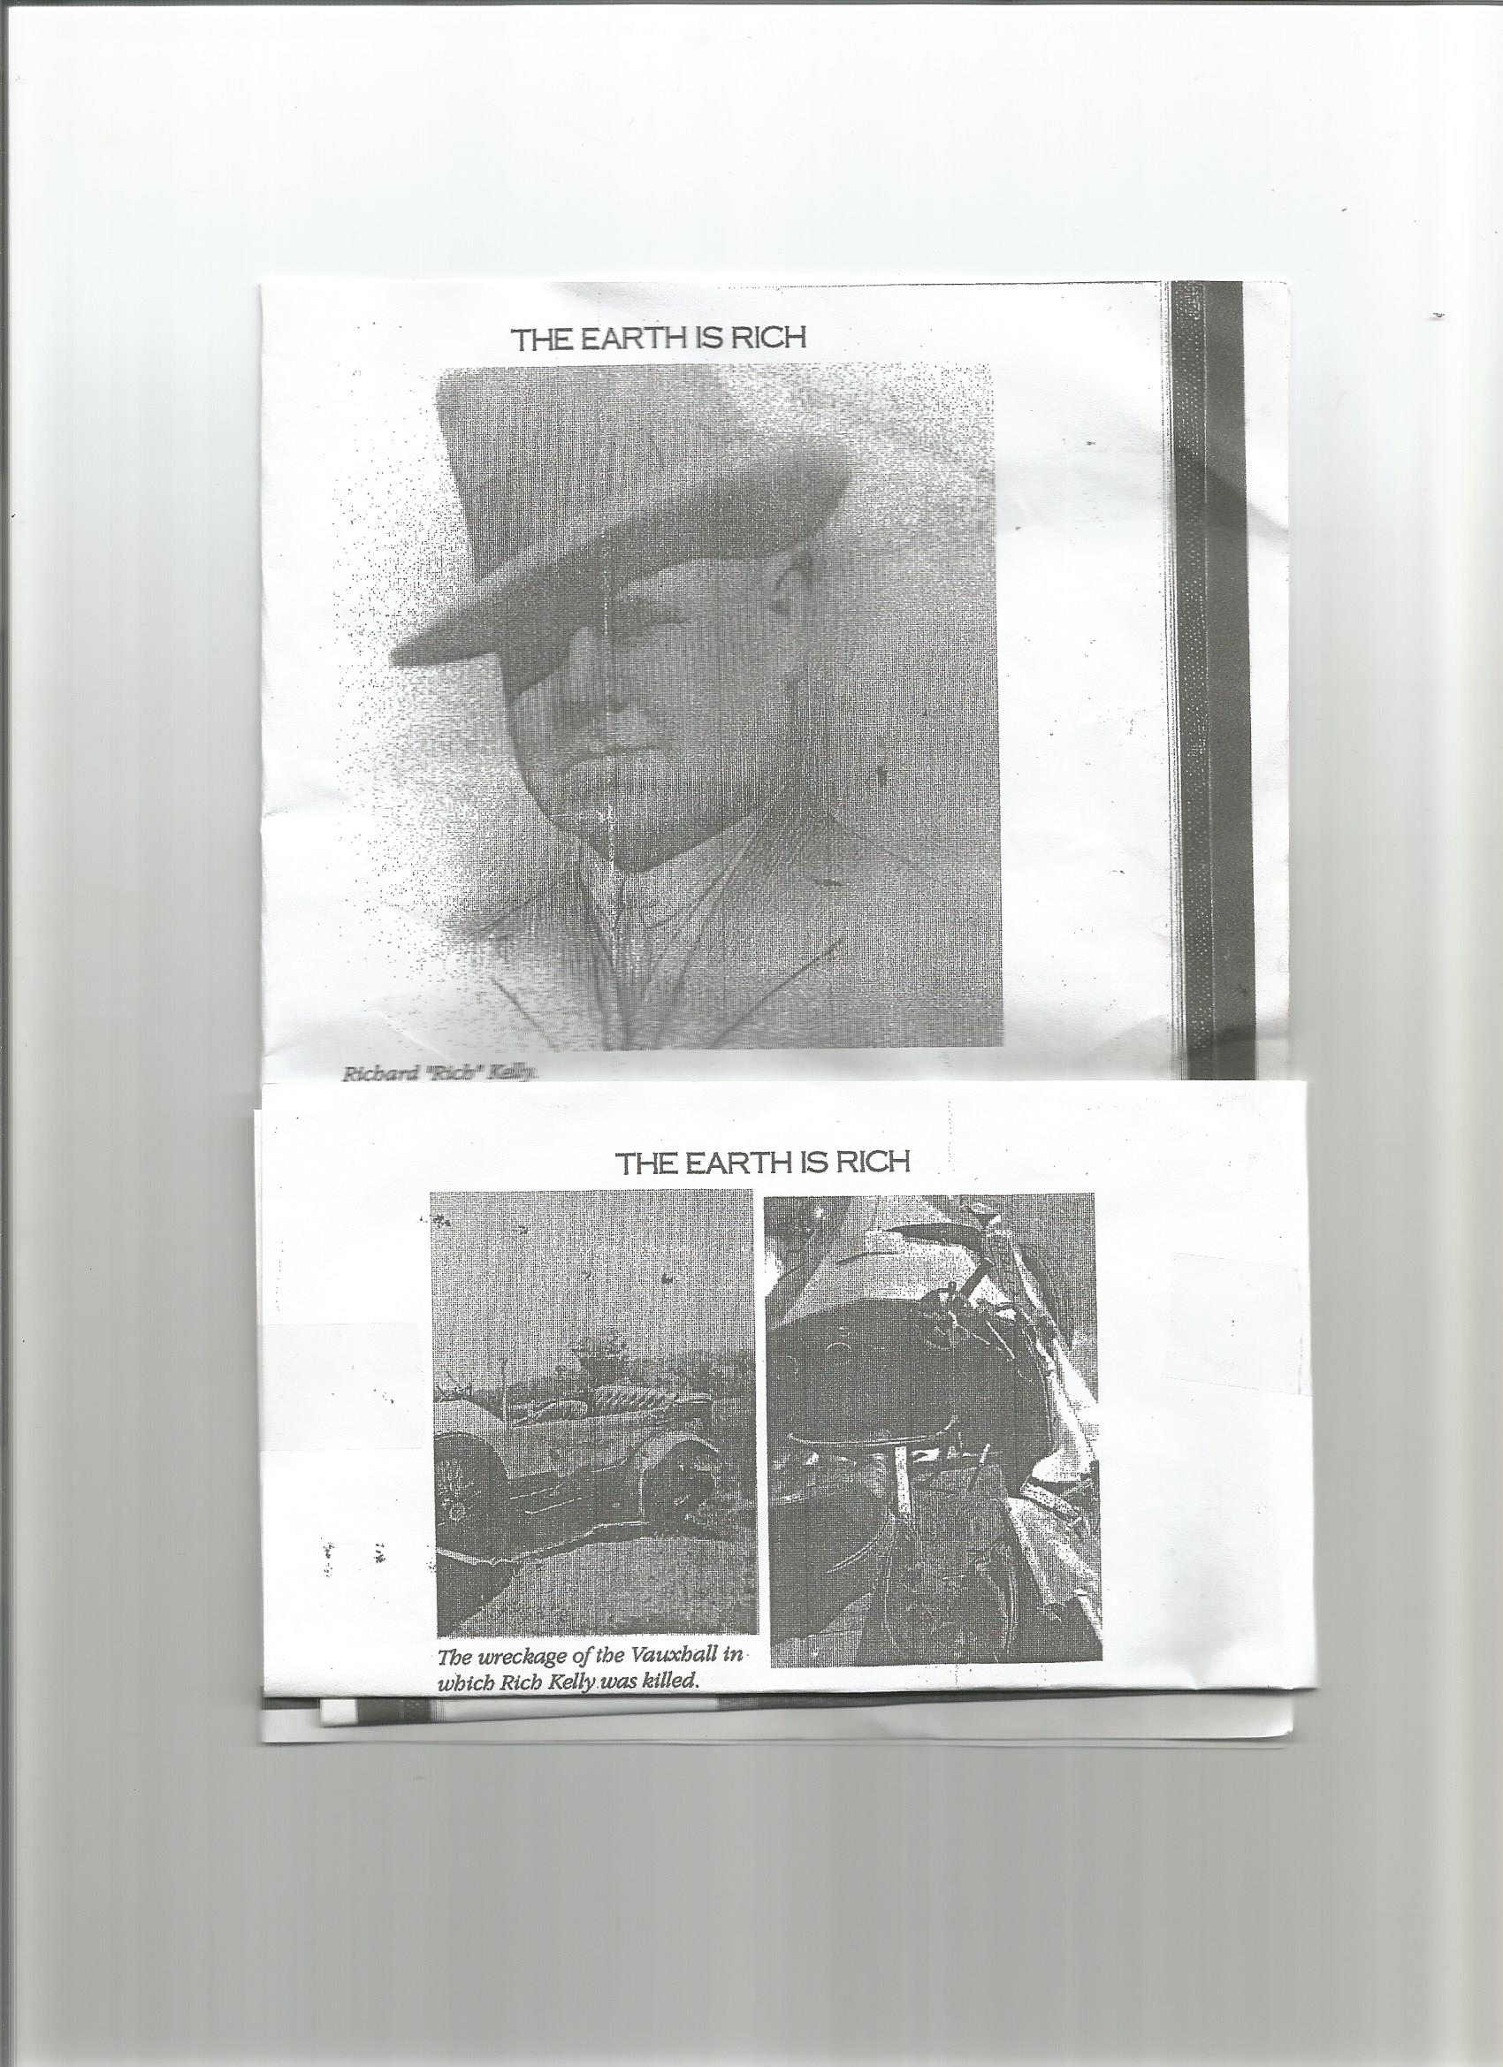

So, the end result is that although Bill Kelly did know that his grandfather’s brother Rich died from injuries he received in the accident he was not aware of what happened to the car. It was not on Lugano or Riverview so there is no need to hurry out there to check. As you will see from the photograph the 30-98 is not that badly damaged and may have been returned to Boyd Edkins for repair.....who knows. There is no information available to assist with the identification of the car other than it was a new 1926 high radiator model with a polished body and guards. There ends the sad tale of this car unless someone out there has some more information.

THE MYSTERY PHOTO COMPETITION.

I may have advised the outcome of the details of the photographs appearing in the last newsletter, however if you missed it, here it is again. The first photograph is of Harry Hagan and his wife on their wedding day in 1962 and the second photograph is of Harry’s 30-98 and 23-60 in the back yard of his home. Richard Walton was first in with the correct answers and won two air airline tickets for a fortnights fully paid holiday to the middle east – congratulations go to Sticky. Emi refuses to pack.

Now, who can identify the following in the photo appearing below:

- Where is the photograph taken?
- Can you identify the cars?
- What are the names of the five people L to R appearing in the photograph?

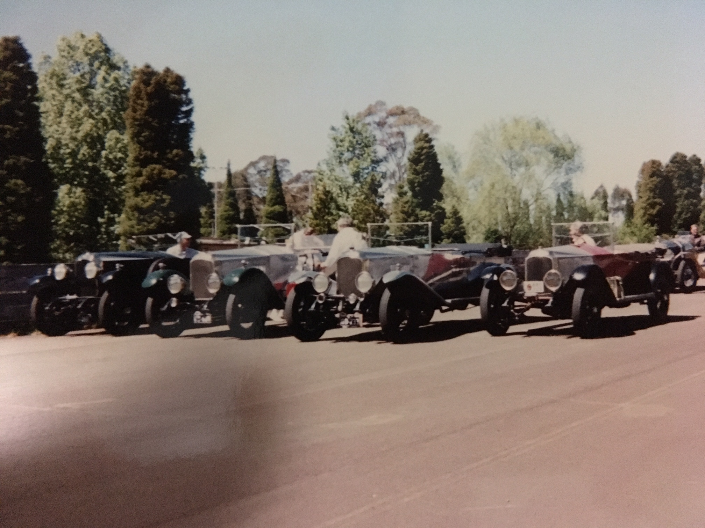

If entering the rally next year please get your entries in early or let me know that you now find you cannot make it. That’s it for May.

Dave Stuart. Mob: 04 2828 2360

